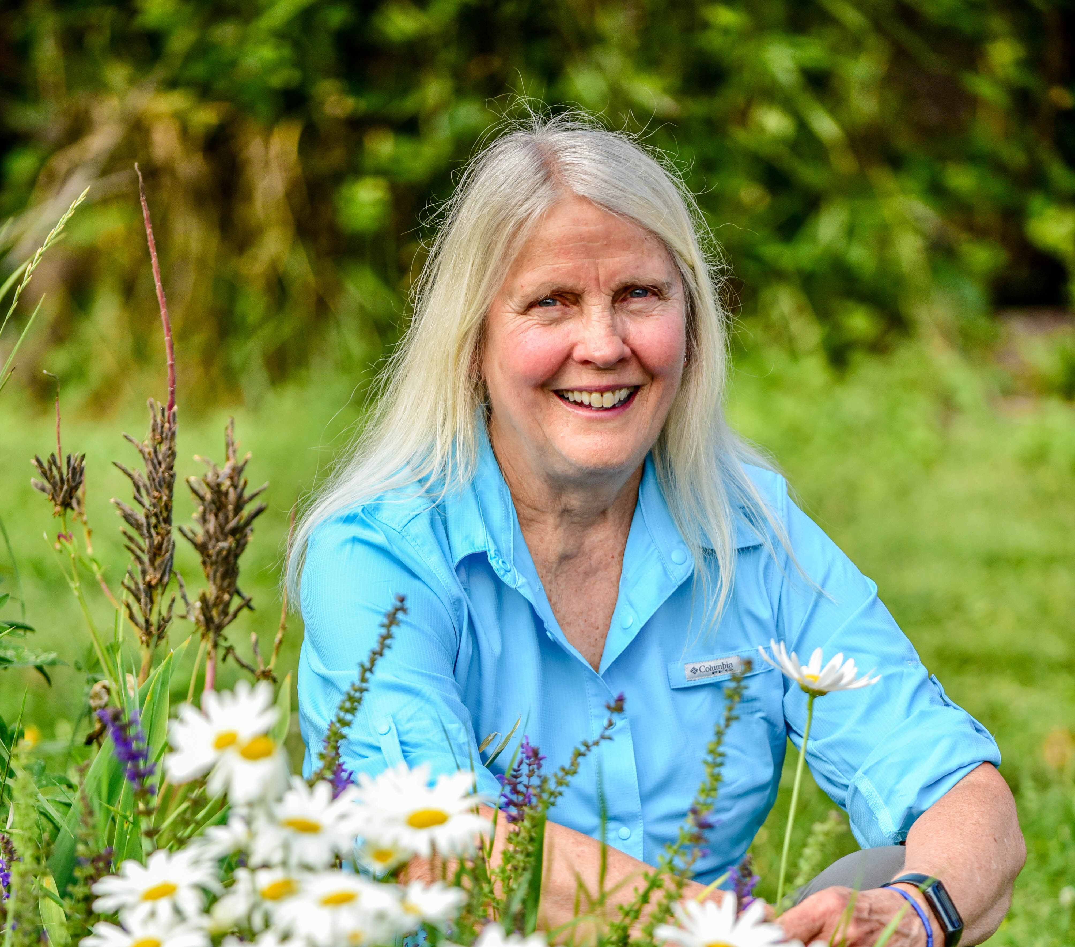




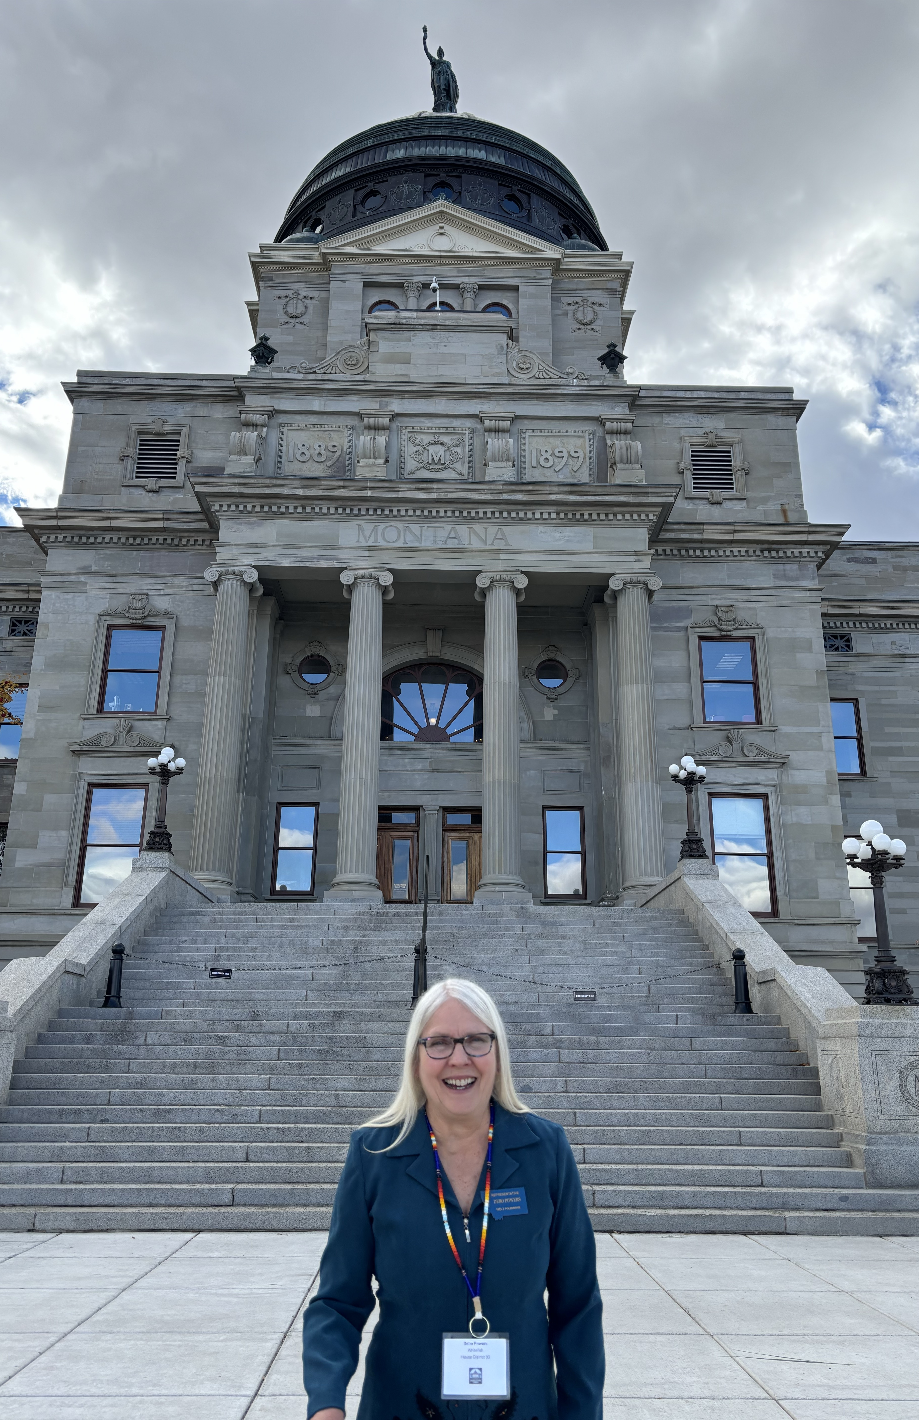


Happy Hour with Debo
Jan Metzmaker’s beautiful yard
915 Dakota Ave (Park on LaBrie)

5:00-7:00

Let’s hold onto House District 3 in the Montana Legislature!
Join us to meet Representative Debo Powers and show your support!
www.powersforthepeople.us
24
July

